**Proposal:**

1. Description:

* Functional requirements: must be wearable, able to tell shades of colors, needs to detect how close you are to desired fabric,
* Non-functional requirements: lightweight, user friendly, not too loud/ abrasive, comfortable to wear, relatively fashionable, should allow user to still feel material
* Constraints: budget, time limit, programming ability(no AI), no ability to tell fabric
* Sensors (inputs):
  + RGB sensor - detects the color of the clothing the user is trying to scan
  + Ultrasonic sensor - detects how close or far the product is from the clothing to know when the product should or should not actively running
  + Button - power button that runs the programs when pressed and then stops when pressed again
* Outputs:
  + Vibrator motor - the purpose is to give the user a subtle buzz or vibration when the user is close enough to the clothing and the sensors are scanning
  + Speaker - will tell the user what color the clothing is with different phrases and say to the user the possible color matching options that go well together.
* Product List:
  + Sturdy Black Glove : <https://a.co/d/7QPdKWY>
  + Button input
  + Small speaker : <https://a.co/d/5rfSYvP>
  + Ultrasonic sensor
  + RGB sensor
  + Vibration motor
  + Raspberry Pi
  + Wires
  + Super glue : <https://a.co/d/5rfSYvP>

1. Sketch:

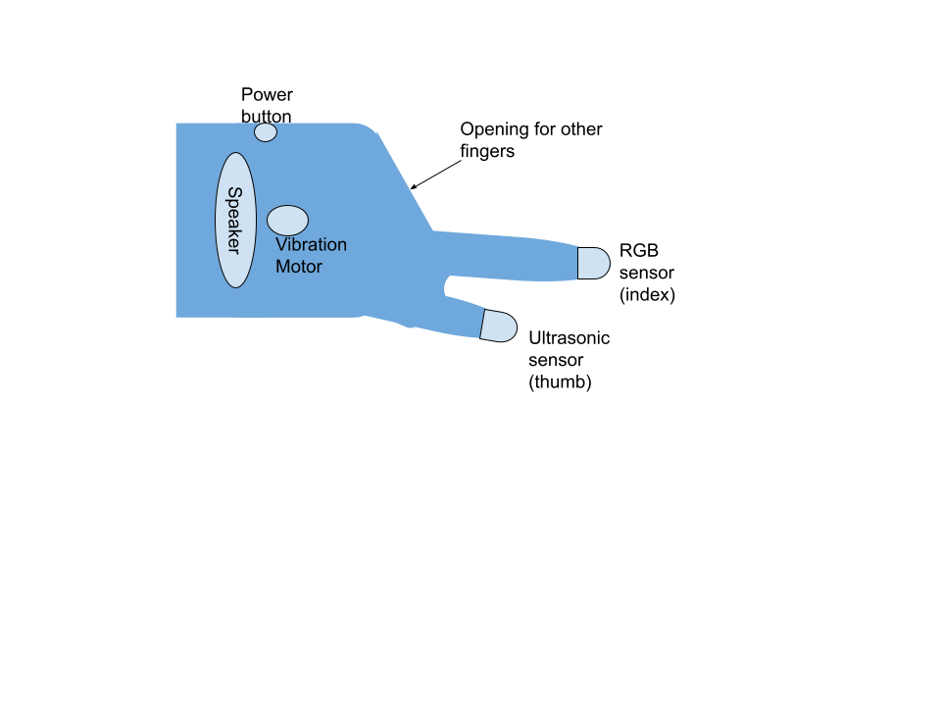

1. State Diagram:

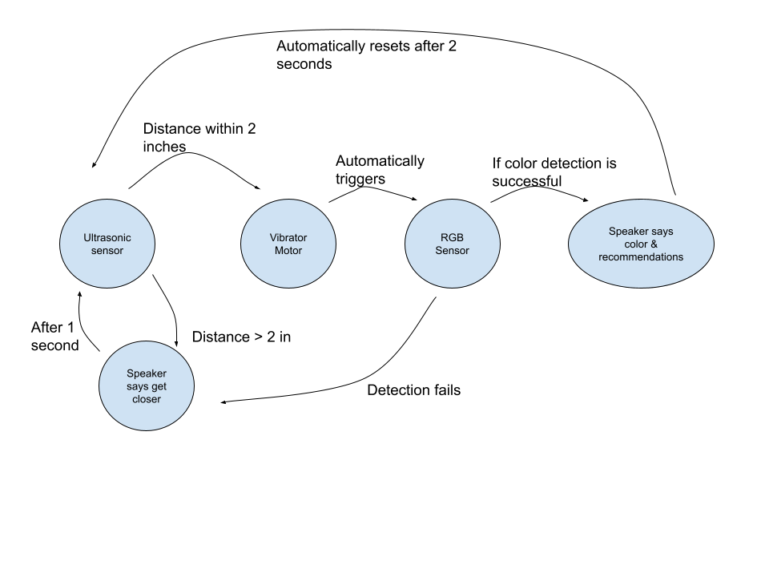

1. Gantt Chart / Project Plan:

<https://docs.google.com/spreadsheets/d/12otIYmgZJvqgUEToSNDwGjA-ZpEUDji5/edit?usp=sharing&ouid=101160863970726712975&rtpof=true&sd=true>